APP HERO QUEST

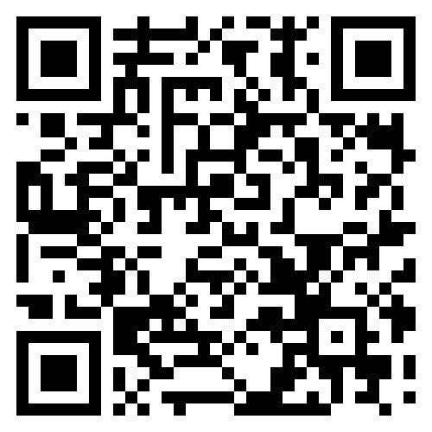

APP HERO QUEST



